**LEBANESE AMERICAN UNIVERSITY**

**USAID – HIGHER EDUCATION SCHOLARSHIP PROGRAM**

**HES - Volunteering Program Verification Form**

This form is to be used to document volunteering hours. If a student volunteers for multiple organizations, a separate form must be used for each organization. **This form must be turned in by the 28th of each month, the latest.**

I certify that the scholar Mariam kafel completed a total of 5 hours of service at InnovaThrive.

The hours were completed hours as per the below:

Hours # 5 (date) _2/12 – 6/12_ (initials of supervisor) __A.K.___

Hours # 0 (date) _9/12 – 13/12_ (initials of supervisor) __A.K.___

Hours # 0 date) _16/12 – 20/12 (initials of supervisor) __A.K.___

Hours # 0 date) _23/12 - 27/12 (initials of supervisor) __A.K.___

Brief description of the activities the scholar performed or participated in:

AI is enhancing forest fire prediction and management by analyzing weather patterns, monitoring vegetation health, and enabling real-time detection with drones. These technologies improve early detection by 40%, reduce wildfire impacts, and enhance safety. However, high costs and data accuracy challenges hinder wider adoption. Future advancements aim to integrate AI with satellite data and predict climate change impacts for more effective global fire management.

Written feedback about the scholar’s performance:

Mariam displays a deep understanding of AI’s potential in forest fire management, emphasizing both technological advancements and challenges. Her research showcases critical thinking and the ability to synthesize complex information.

Please rate the overall performance of the scholar at your organization:

|  |  |  |  |
| --- | --- | --- | --- |
|  | Mastery (5) | Proficient (3) | Emerging (1) |
| **Problem solver** | X |  |  |
| **Engaged & Committed** | X |  |  |
| **Open-minded & multicultural** | X |  |  |

Signature

& stamp

__________________________

_

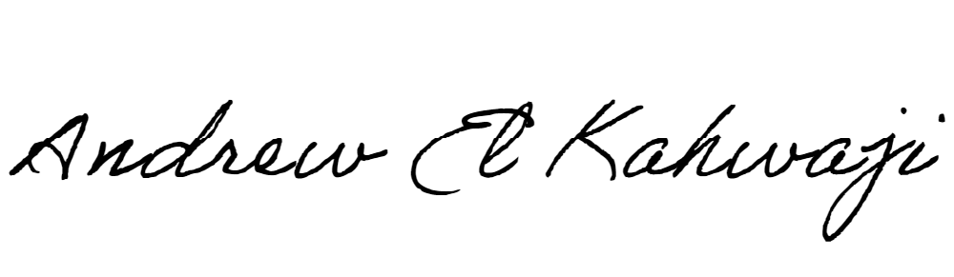

Printed Name _Andrew El Kahwaji_

Date __26/12/2024___

Email __andrew.lifesculptor.coo@gmail.com __

Phone __+961 71 914 378__